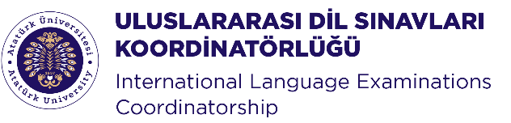
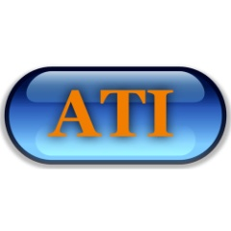
Anatolia Training Institute, Ankara

Webinar:
Continuing Professional Development through CELTA and DELTA

Dr. Simon Phipps, Anatolia Training Institute (ATI), Ankara
Tuesday 5 January, 2021, 13.30-14.30

In this webinar we will outline how Cambridge qualifications such as CELTA and DELTA can provide valuable continuing professional development (CPD) opportunities for teachers working in universities in Turkey. Both these courses can currently be taken fully online. We will describe how both courses work, who they are aimed at, and how they can contribute to personal as well as institutional development.

Ataturk University International Language Examinations Coordinatorship. (ATAILE) was established to help students and academic staff learn languages and prove their skills to the world..
https://ataile.atauni.edu.tr/

Anatolia Training Institute (ATI), Ankara has been providing Teacher Training courses and Educational Consultancy since 2014. We have delivered CELTA and DELTA courses at a number of different universities in Ankara, Eskisehir, Antalya and Karabuk.
www.ati-ankara.com

Dr. Simon Phipps is Director of ATI (Anatolia Training Institute) in Ankara, which provides teacher training and educational consultancy. He has been Principal Examiner for Delta Module 3 since 2008 and an External Examiner for Delta Module since 1997. He has been a Delta trainer since 1994 and a CELTA trainer since 2014.

He previously worked as Deputy Director of Bilkent University School of English Language in Ankara for 20 years, where he was responsible for in-service teacher training and development. He designed and directed an in-house MA programme (Management in Education in ELT), and taught MA courses on linguistics, lexis and educational management. He has worked in ELT in the UK, Germany and Turkey since 1984, and has been involved in teacher education since 1989. He has a PhD in Education, from the University of Leeds, UK, with a focus on teacher beliefs. His current professional interests include teacher cognition, teacher learning, teacher education research, and educational management.

Registration: https://tinyurl.com/ataile

